**Reuse and Social Adaptation of New Immigrants in Israel: The Experience of Nahariya**

© **Bela Nikitina**, Research Fellow,

Natural Resources and Environmental Research Center, University of Haifa

**Introduction**

Modern life in Israel is characterized by a high level of consumption and, as a result, by large volumes of household waste. At the same time, the country lacks a sustainable system for redistributing items that could be reused. Every year, thousands of pieces of furniture, household appliances, and clothing are thrown into the streets, where they lose their value, deteriorate under the open sky, and eventually end up in landfills.  
This situation not only increases the burden on the waste management system but also reduces the potential for developing a sharing economy — the exchange of goods, services, and resources based on mutual benefit and trust.

For new immigrants (olim hadashim), the issue of household arrangement becomes one of the key challenges of adaptation. People arrive without furniture, appliances, or even basic household items. Under these conditions, reuse, gifting, and local support communities become essential mechanisms of social integration and environmental sustainability.

Methodology

The author of this study — a sociologist and new immigrant — lived in the city of Nahariya in 2023.  
During her personal adaptation experience, she encountered the activity of local WhatsApp groups for new immigrants.  
Through these groups, the author invited participants to take part in a survey aimed at studying how repatriates solve housing arrangement issues: where they find furniture and appliances, how they assess the quality of received items, and whether they are willing to participate in exchange themselves.  
The survey was conducted from March to December 2023 and covered 203 respondents.

Research Results

The study showed that the majority of new immigrants face a shortage of furniture and household appliances.  
Only 12.5% of participants moved into fully furnished apartments, while half of the respondents received housing without any furniture at all.

**Fig. 1. Furnishing of new immigrants’ housing**

Among those who furnished their homes independently, 55% received household appliances for free or at a symbolic price, and 57% obtained furniture in a similar way.  
This indicates the important role of informal exchange channels — from gifting groups to personal contacts.

**Fig. 2. Acquisition of household appliances**

**Fig. 3. Acquisition of furniture**

The quality of the received items is mostly satisfactory:  
a third of respondents are fully satisfied, another 40% are partially satisfied, and only 9% expressed dissatisfaction.  
This demonstrates a high degree of readiness to use second-hand items and trust in such practices.

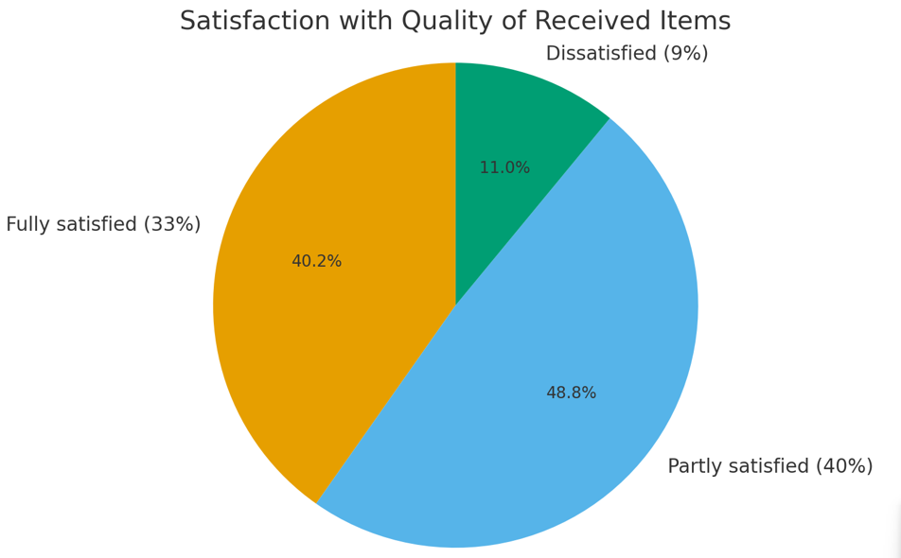

**Fig. 4. Satisfaction with the quality of received items**

Most participants (92%) prefer to give away unnecessary items to other people for free,  
while 12% choose charitable organizations and 18% use special containers.  
Thus, gifting and personal exchange appear to be the main ways of handling items that have lost value for their owners.

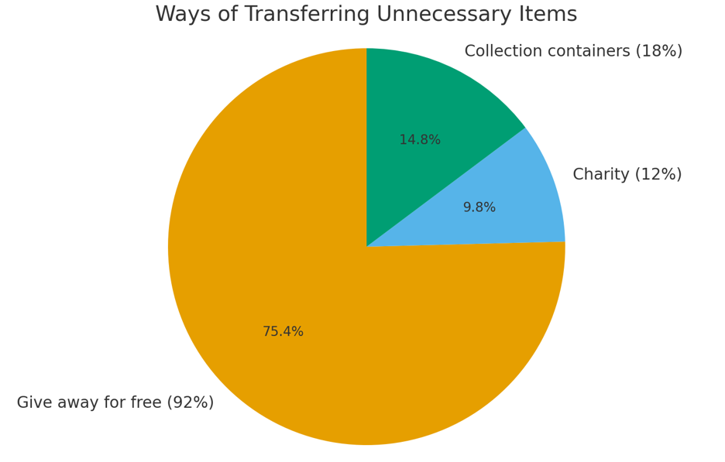

**Fig. 5. Methods of transferring unnecessary items**

**Conclusions and Discussion**

The data analysis shows that among Russian-speaking new immigrants there is a high willingness to reuse items,  
but no institutionalized mechanisms exist for this purpose.  
There is no unified system for transferring furniture and appliances to new users, and existing initiatives are fragmented and often depend on the enthusiasm of individuals.  
The lack of infrastructure for the sharing economy leads to many items being discarded, even though they could be useful to others.

The creation of municipal and community programs for item redistribution — such as exchange centers, Repair Cafés, and online donation platforms —  
would contribute not only to waste reduction but also to strengthening social cohesion.  
In the context of growing interest in the circular economy and sustainable lifestyles, such initiatives could become an important element of urban resilience and the integration of new residents of Israel.

Prepared within the framework of the RE-Haifa Hub initiative | 2025